**Module 8: Portfolio Milestone**

Chioma Chance

CSC500

08/03/2024

# Introduction

Module 8 Portfolio Project was the collection of all the portfolios in one. We started with an ItemToPurchase class then moved on to the ShoppingCart class. The purpose of this project was to make sure each of the classes are working properly for user engagement. I updated everything that needed fixing, and made sure each item in my menu worked properly.

## **Source Code**

# Online Shopping Cart

class ItemToPurchase:

    def __init__(self, name = 'none', price = 0.0, quantity = 0):

        self.item_name = name

        self.item_price = price

        self.item_quantity = quantity

    def print_item_cost(self):

        total_cost = self.item_price * self.item_quantity

        return f'{self.item_name} {self.item_quantity} @ ${self.item_price} = ${total_cost:.2f}'

# part 4: add new shoping cart class

class ShoppingCart:

    def __init__(self, customer_name = 'none', current_date = 'January 1, 2020'):

        self.customer_name = customer_name #attribute 1

        self.current_date = current_date #attribute 2

        self.cart_items = [] #attribute 3

    def add_item(self, item_to_purchase: ItemToPurchase):

        self.cart_items.append(item_to_purchase)

    def remove_item(self, item_name: str):

        for item in self.cart_items:

            if item.item_name == item_name:

                self.cart_items.remove(item)

                return

        print('Item not found in cart. Nothing removed')

    def modify_item(self, item_to_purchase: ItemToPurchase):

        for item in self.cart_items:

            if item.item_name == item_to_purchase.item_name:

                if item_to_purchase.item_price != 0.0:

                    item.item_price = item_to_purchase.item_price

                if item_to_purchase.item_quantity != 0:

                    item.item_quantity = item_to_purchase.item_quantity

                return

        print('Item not found in cart. Nothing modified.')

    def get_num_items_in_cart(self):

        return sum(item.item_quantity for item in self.cart_items)

    def get_cost_of_cart(self):

        return sum(item.item_price * item.item_quantity for item in

        self.cart_items)

    def print_total(self):

        if not self.cart_items:

            print('SHOPPING CART IS EMPTY')

        else:

            print(f"{self.customer_name}'s Shopping Cart - {self.current_date}\n")

            total_items = self.get_num_items_in_cart()

            total_cost = self.get_cost_of_cart()

            print(f'Number of Items: {total_items}\n')

            for item in self.cart_items:

                print(item.print_item_cost())

            print(f'\nTotal: ${total_cost:.2f}')

    def print_descriptions(self):

        print(f'{self.customer_name} - {self.current_date}\n')

        print('Item Descriptions\n')

        for item in self.cart_items:

            description = getattr(item, 'description', 'No description available')

            print(f'{item.item_name}: {description}')

# part 5

def print_menu(shopping_cart: ShoppingCart):

    print('\nMENU')

    print('q - Quit\n')

    print('a - Add item to cart\n')

    print('r - Remove item from cart\n')

    print('c - Change item quantity\n')

    print('i - Output items\' descriptions\n')

    print('o - Output shopping cart\n')

    print('Choose an option: ', end='')

# def main: implement instructions for menu

def main():

    print('Welcome to the online Shopping Cart\n')

    #user input for name

    customer_name = input('Please enter your name:\n')

    current_date = input('Please enter today\'s date:\n')

    cart = ShoppingCart(customer_name, current_date)

    print(f'Customers name: {customer_name}')

    print(f'Today\'s date: {current_date}')

    while True:

        print_menu(cart)

        # make sure there are no proceeding spaces and letters are lowercase

        choice = input().strip().lower()

        if choice == 'a':

            name = input('Enter item name:\n')

            description = input('Enter product description:\n')

            price = float(input('Enter the item price:\n'))

            quantity = int(input('Enter the item quantity:\n'))

            item = ItemToPurchase(name, price, quantity)

            item.description = description

            cart.add_item(item)

            print(f'Added {name} to cart.')

        elif choice == 'r':

            # remove item

            name = input('Enter item name to remove: ')

            cart.remove_item(name)

            print('Item removed')

        elif choice == 'c':

            # change item quantity

            name = input('Enter name of item you want to modify: ')

            new_quantity = int(input('Enter new quantity: '))

            item_to_modify = ItemToPurchase(name,0.0, new_quantity)

            cart.modify_item(item_to_modify)

            print('Item quantity modified to {new_quantity}')

        elif choice == 'i':

            cart.print_descriptions()

        elif choice == 'o':

            cart.print_total()

        elif choice == 'q':

            # quit program

            print('Thank you for using the virtual shopping cart, enjoy :)')

            break

        else:

            print('Invalid option, plaese try again.')

# call main function to action

if __name__ == '__main__':

    main()

# **Pseudocode**

Class ItemToPurchase:

Function __init__(name = 'none', price = 0.0, quantity = 0):

Set self.item_name to name

Set self.item_price to price

Set self.item_quantity to quantity

Function print_item_cost():

Set total_cost to self.item_price * self.item_quantity

Return formatted string of item_name, item_quantity, item_price, and total_cost

Class ShoppingCart:

Function __init__(customer_name = 'none', current_date = 'January 1, 2020'):

Set self.customer_name to customer_name

Set self.current_date to current_date

Set self.cart_items to empty list

Function add_item(item_to_purchase):

Append item_to_purchase to self.cart_items

Function remove_item(item_name):

For each item in self.cart_items:

If item.item_name equals item_name:

Remove item from self.cart_items

Return

Print 'Item not found in cart. Nothing removed'

Function modify_item(item_to_purchase):

For each item in self.cart_items:

If item.item_name equals item_to_purchase.item_name:

If item_to_purchase.item_price is not 0.0:

Set item.item_price to item_to_purchase.item_price

If item_to_purchase.item_quantity is not 0:

Set item.item_quantity to item_to_purchase.item_quantity

Return

Print 'Item not found in cart. Nothing modified.'

Function get_num_items_in_cart():

Return sum of item.item_quantity for each item in self.cart_items

Function get_cost_of_cart():

Return sum of item.item_price * item.item_quantity for each item in self.cart_items

Function print_total():

If self.cart_items is empty:

Print 'SHOPPING CART IS EMPTY'

Else:

Print customer_name and current_date

Set total_items to result of get_num_items_in_cart

Set total_cost to result of get_cost_of_cart

Print 'Number of Items:', total_items

For each item in self.cart_items:

Print item.print_item_cost()

Print 'Total:', total_cost

Function print_descriptions():

Print customer_name and current_date

Print 'Item Descriptions'

For each item in self.cart_items:

Set description to item.description if exists else 'No description available'

Print item.item_name and description

Function print_menu(shopping_cart):

Print menu options

Function main():

Print welcome message

Input customer_name

Input current_date

Create ShoppingCart object cart with customer_name and current_date

Print customer_name and current_date

While True:

Call print_menu(cart)

Input choice and convert to lowercase

If choice equals 'a':

Input item name

Input item description

Input item price and convert to float

Input item quantity and convert to integer

Create ItemToPurchase object item with name, price, and quantity

Set item.description to description

Call cart.add_item(item)

Print 'Added {name} to cart.'

Else If choice equals 'r':

Input item name to remove

Call cart.remove_item(name)

Print 'Item removed'

Else If choice equals 'c':

Input item name to modify

Input new quantity and convert to integer

Create ItemToPurchase object item_to_modify with name, 0.0, and new_quantity

Call cart.modify_item(item_to_modify)

Print 'Item quantity modified to {new_quantity}'

Else If choice equals 'i':

Call cart.print_descriptions()

Else If choice equals 'o':

Call cart.print_total()

Else If choice equals 'q':

Print 'Thank you for using the virtual shopping cart, enjoy :)'

Break

Else:

Print 'Invalid option, please try again.'

Call main function if __name__ equals '__main__':

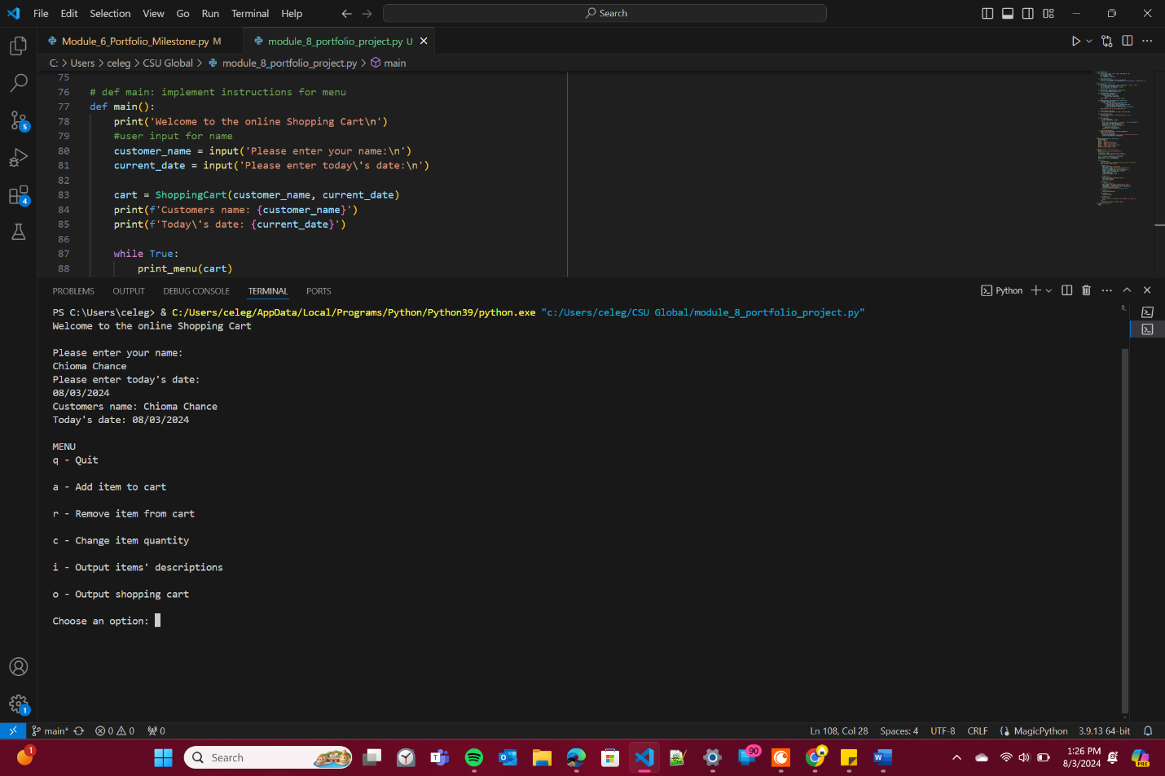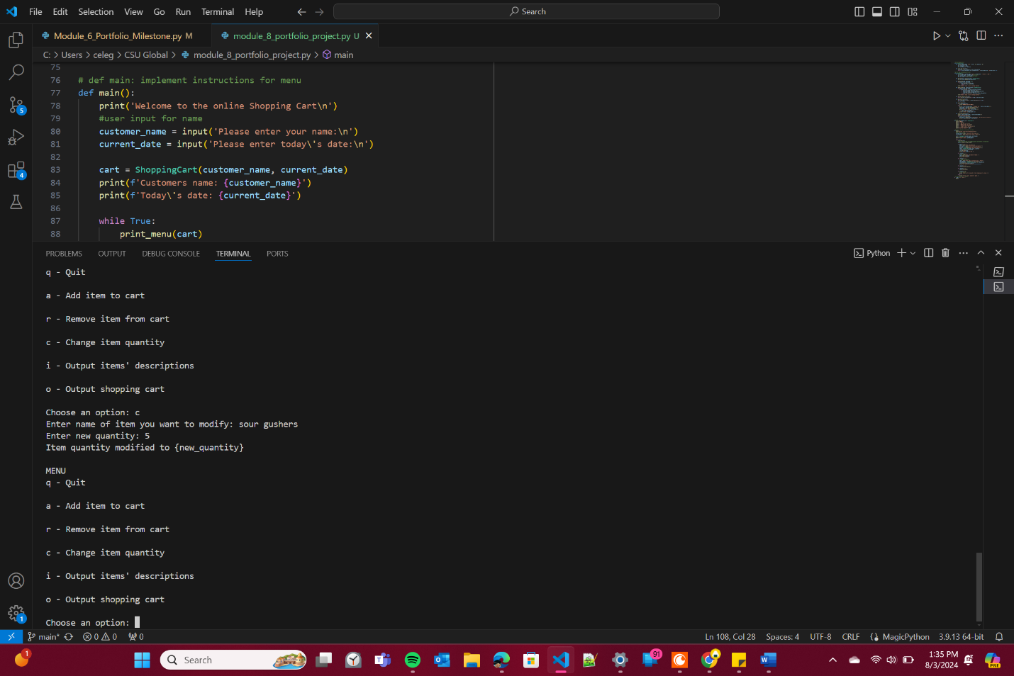**GIT repository link**

<https://github.com/Ch1T1me/CSC500.git>

# **Challenges**

I didn't face any challenges in this project, thanks to all the hard work done in Module 6. During Module 6, I encountered numerous difficulties but, with diligence and valuable feedback from you, Dr. Evans, I was able to overcome them. This week was mainly about writing up my findings and reflecting on the learning process. I've gained so many new skills throughout this course and these projects, and I truly appreciate the guidance and support provided. Thank you.

**References**

CSC500 Principles of Programming. (n.d.). In ZyBooks. Retrieved from <https://learn.zybooks.com/zybook/CSUGLOBALCSC500MASTER1>

OpenAI. (2023). ChatGPT (July 2023 version) [Large language model]. Retrieved from <https://www.openai.com/chatgpt>

• "9. Classes." *Python Documentation*, Python Software Foundation, <https://docs.python.org/3/tutorial/classes.html>. Accessed 3 Aug. 2024.

• "Python String." *GeeksforGeeks*, <https://www.geeksforgeeks.org/python-string/>. Accessed 3 Aug. 2024.